WEEK 2 INTERNSHIP TASK
Exploratory Data Analysis and Visualization
Project: Telco Customer Churn
Submitted by: K. Avinash
Program: B.Tech Computer Science and Engineering
Domain: Data Analytics and Machine Learning
Week: 2
Internship Name :- Virtual Data Science Apprentice Intern

1. Objective
The objective of Week 2 is to perform an in-depth Exploratory Data Analysis (EDA) and visualization of the Telco Customer Churn dataset using Python. The analysis examines the structure and quality of the dataset, distributions of important variables, relationships between numerical features, customer segmentation, and differences between customers who churned and those who remained. The goal is to convert the raw dataset into clear, evidence-based insights that can support later data analysis and machine-learning work.

2. Dataset Overview
The dataset contains customer-level information related to demographic details, services, contract arrangements, billing/payment methods, tenure, monthly charges, total charges, and the Churn outcome.
Characteristic | Result | Interpretation
Rows | 7,043 | Each row represents a customer record.
Columns | 21 | Includes customer, service, billing and churn variables.
Missing values | 0 | No missing values were detected by Pandas.
Exact duplicate rows | 0 | No exact duplicate records were found.
Churn = No | 5,174 (73.46%) | Customers who did not churn.
Churn = Yes | 1,869 (26.54%) | Customers who churned.

3. Data Validation and Quality Checks

3.1 Missing Values
The missing-value check returned an empty Series, and the total number of missing values was 0. Therefore, no missing-value imputation was required for the EDA.

3.2 Duplicate Records
The exact duplicate-row check returned 0 duplicate rows. This indicates that the dataset did not contain identical records that needed to be removed.

3.3 Unique Values
The unique-value analysis showed that binary variables such as gender, SeniorCitizen, Partner, Dependents, PhoneService, PaperlessBilling and Churn contain 2 unique values. Several service variables contain 3 categories, while PaymentMethod contains 4 categories. The numerical variables show substantially larger cardinality: tenure has 73 unique values, MonthlyCharges has 1,585, TotalCharges has 6,531, and customerID has 7,043.

3.4 TotalCharges Data-Type Validation
A specific validation was performed for TotalCharges because its original data type was object rather than numeric. Converting the column to numeric revealed 11 values that could not be converted. The 11 affected records had tenure = 0 and Churn = No. The invalid values were blank strings rather than meaningful numeric charge amounts. For numerical EDA, TotalCharges was converted to numeric so that its distribution, correlation and outlier statistics could be calculated.

4. Descriptive Statistics
For the numerical variables, the dataset contained 7,043 observations. The main descriptive statistics were:
Feature | Mean | Median | Range
tenure | 32.3711 | 29.0000 | 0–72 months
MonthlyCharges | 64.7617 | 70.3500 | 18.25–118.75
TotalCharges | ≈2,281 (after numeric conversion) | ≈1,397 | 0–≈8,684
The exact TotalCharges mean/median are not reproduced here because the analysis outputs supplied for the report focused on its distribution, correlations and IQR results rather than printing those two summary values.

5. Churn Distribution
The target variable contains 5,174 customers who did not churn and 1,869 customers who churned. This corresponds to 73.46% non-churn and 26.54% churn. The target is therefore imbalanced, although the minority class is large enough to support meaningful EDA and subsequent modelling.

6. Numerical Feature Distributions

6.1 Customer Tenure Distribution
Tenure ranges from 0 to 72 months. The histogram shows a high concentration of customers at very short tenure and another substantial concentration near the upper end of the tenure range. The mean is 32.37 months and the median is 29 months.
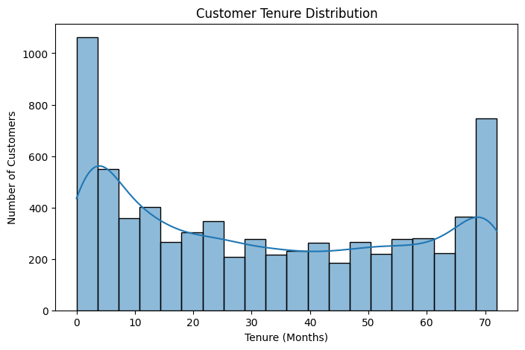

6.2 Monthly Charges Distribution
MonthlyCharges ranges from 18.25 to 118.75. The distribution contains a large peak around the lower charge range and a broader concentration through the middle and higher charge ranges. The mean is 64.76 and the median is 70.35.
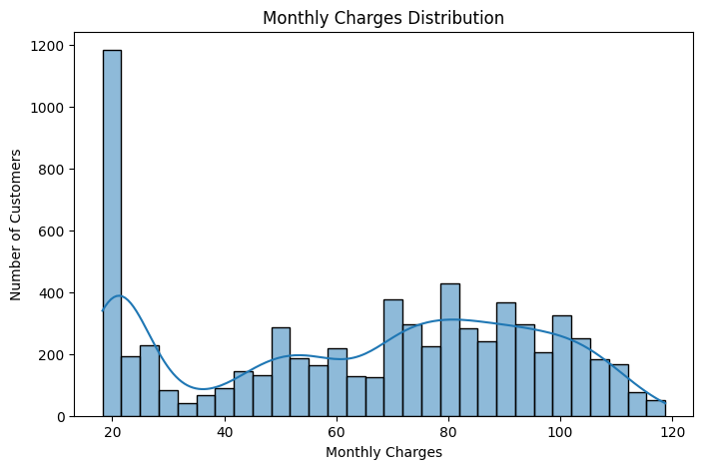

6.3 Total Charges Distribution
After converting TotalCharges to numeric values, the distribution is strongly right-skewed. A large number of customers have relatively low accumulated charges, while progressively fewer customers have very high total charges. This pattern is consistent with the relationship between total charges and customer tenure.

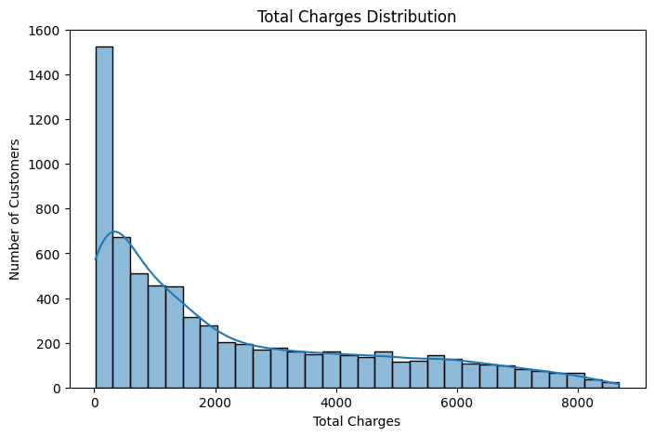

7. Categorical Feature Distributions

7.1 Contract Type
Month-to-month contracts are the largest group with 3,875 customers, followed by two-year contracts with 1,695 and one-year contracts with 1,473.
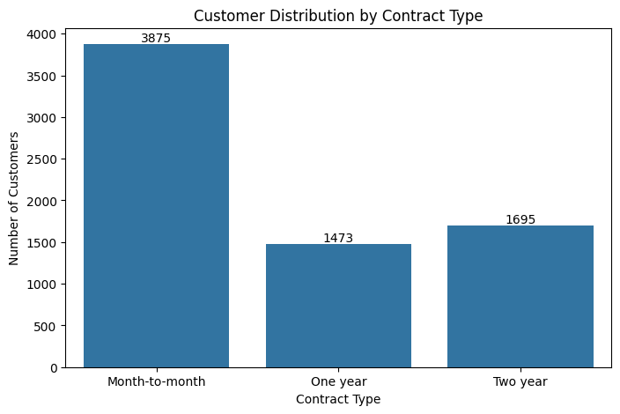

7.2 Internet Service
Fiber optic is the largest internet-service category with 3,096 customers, followed by DSL with 2,421 and customers with no internet service with 1,526.
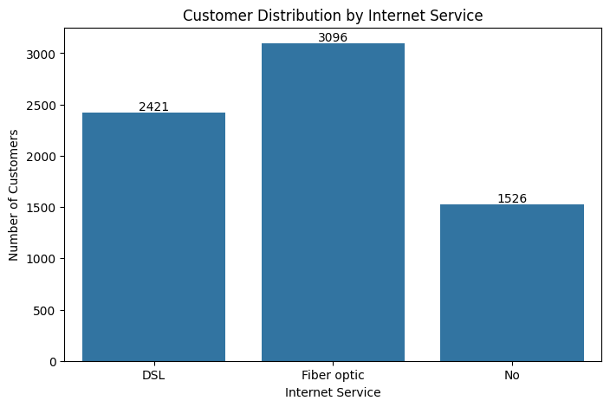

7.3 Payment Method
Electronic check is the most common payment method with 2,365 customers. Mailed check has 1,612 customers, bank transfer (automatic) has 1,544, and credit card (automatic) has 1,522.
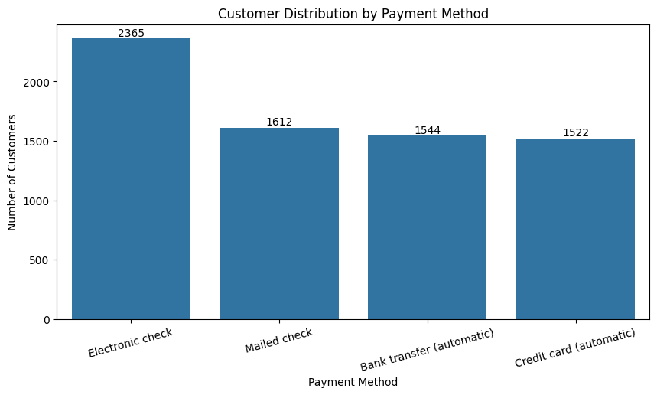

8. Churn Analysis by Customer Segments

8.1 Churn by Contract Type
The churn-rate analysis shows a strong difference by contract type. Month-to-month customers have a 42.71% churn rate, compared with 11.27% for one-year contracts and only 2.83% for two-year contracts. This is one of the clearest segment-level patterns in the EDA.
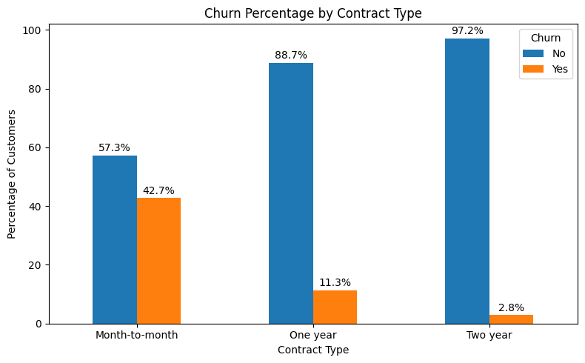

8.2 Churn by Internet Service
Fiber-optic customers have the highest churn rate among the internet-service groups at 41.89%. DSL customers have a churn rate of 18.96%, while customers with no internet service have a churn rate of 7.40%.
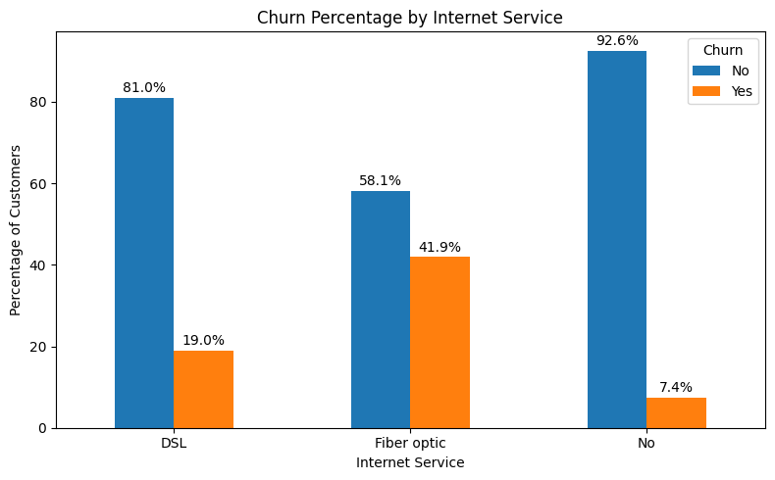

8.3 Churn by Payment Method
Electronic check customers show the highest churn rate at 45.29%. The rates for mailed check, bank transfer (automatic), and credit card (automatic) are 19.11%, 16.71%, and 15.24%, respectively.
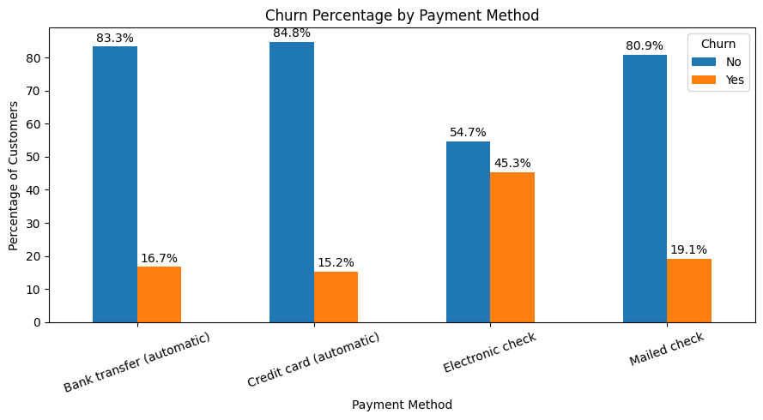

9. Numerical Features vs Churn

9.1 Tenure by Churn Status
Customers who did not churn have a mean tenure of 37.57 months and a median of 38 months. Customers who churned have a much lower mean tenure of 17.98 months and median of 10 months. The distributions therefore indicate that churn is more concentrated among customers with shorter tenure.
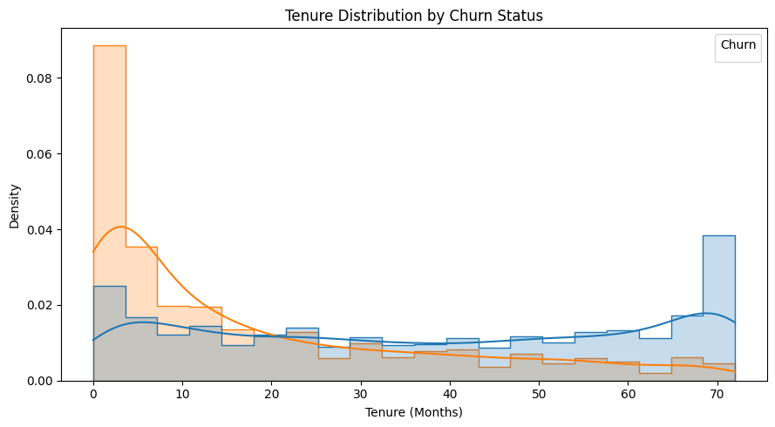

9.2 Monthly Charges by Churn Status
Customers who churned have higher monthly charges on average. The mean MonthlyCharges is 74.44 for churned customers compared with 61.27 for customers who did not churn. The medians are 79.65 and 64.43, respectively.
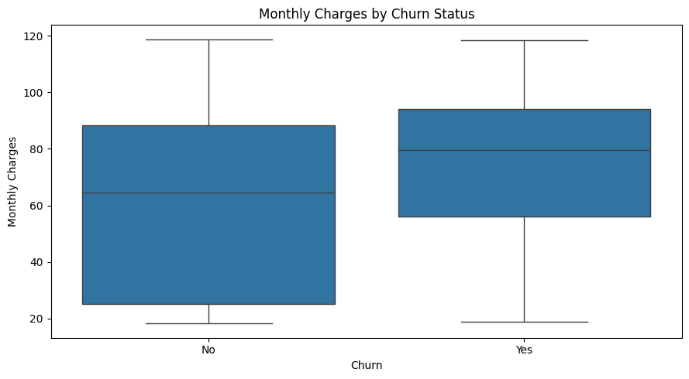

10. Correlation Analysis
A Pearson correlation matrix was calculated for tenure, MonthlyCharges, TotalCharges, and a numeric representation of Churn. The correlation with Churn_Numeric was:
Feature | Correlation with Churn_Numeric
tenure | -0.3520
MonthlyCharges | 0.1930
TotalCharges | -0.1990
The strongest relationship with churn among these numerical features is tenure, with a negative correlation of -0.352. This indicates that lower tenure is associated with higher churn in this dataset. MonthlyCharges has a positive correlation of 0.193, while TotalCharges has a negative correlation of -0.199. These are associations rather than causal relationships.
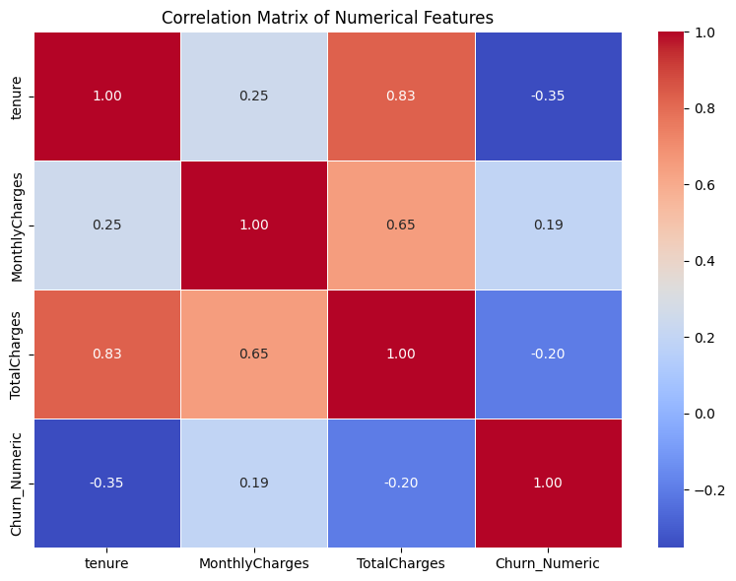

11. Outlier Analysis using the IQR Method
The IQR method was applied to tenure, MonthlyCharges and TotalCharges. The analysis produced the following results:
Feature | Q1 | Q3 | IQR | Bounds | Outliers
tenure | 9.00 | 55.00 | 46.00 | -60.00 to 124.00 | 0 (0.00%)
MonthlyCharges | 35.50 | 89.85 | 54.35 | -46.02 to 171.38 | 0 (0.00%)
TotalCharges | 401.45 | 3794.74 | 3393.29 | -4688.48 to 8884.67 | 0 (0.00%)
No IQR-based outliers were detected for any of the three numerical features. The negative lower bounds for all three variables are mathematically produced by the 1.5×IQR rule and do not imply that negative tenure or charges are valid values.
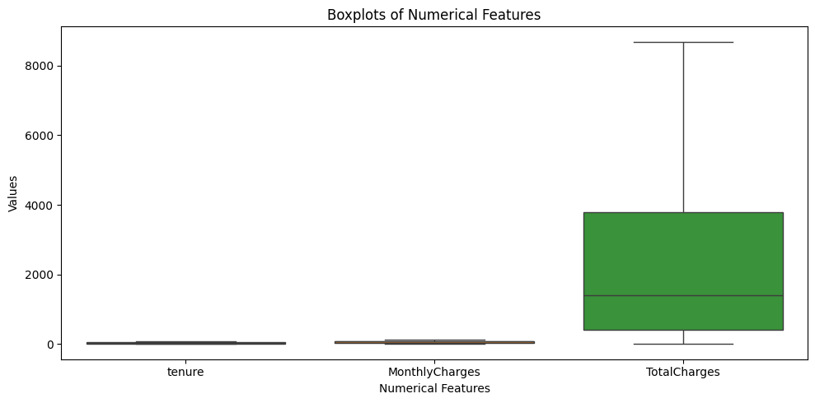

12. Key Findings and Insights
- The dataset contains 7,043 customer records and 21 columns, with 0 missing values and 0 exact duplicate rows.
- The Churn target contains 1,869 churned customers (26.54%) and 5,174 non-churned customers (73.46%).
- Month-to-month contracts show a 42.71% churn rate, far higher than one-year (11.27%) and two-year (2.83%) contracts.
- Fiber-optic customers show a 41.89% churn rate, compared with 18.96% for DSL and 7.40% for customers with no internet service.
- Electronic-check customers show the highest payment-method churn rate at 45.29%.
- Churned customers have substantially lower tenure: mean 17.98 months versus 37.57 months for non-churned customers.
- Churned customers also have higher monthly charges: mean 74.44 versus 61.27 for non-churned customers.
- Tenure has the strongest numerical correlation with Churn_Numeric among the analysed numerical variables (-0.352).
- No IQR-based outliers were detected in tenure, MonthlyCharges or TotalCharges.
- The original TotalCharges column required explicit data-type validation because 11 blank values could not be converted to numeric.

13. Business Implications
The EDA suggests that customer retention efforts should pay particular attention to short-tenure customers, month-to-month contract holders, fiber-optic customers and electronic-check users. These groups show comparatively high churn rates or strong differences in the observed churn patterns. The findings can be used to define segments for deeper investigation and, in a later machine-learning stage, as candidate predictors for churn-risk modelling. The analysis should not be interpreted as proving that any single feature causes churn.

14. Reproducibility and Tools
The analysis was performed in a separate Week 2 notebook using the original Telco Customer Churn dataset. The notebook loads the dataset into a new DataFrame and performs EDA independently; it does not rely on the DataFrame created in the Week 1 notebook. Python libraries used for the analysis include Pandas for data handling and statistics, Matplotlib and Seaborn for visualization.

15. Conclusion
The Week 2 exploratory analysis provided a detailed view of the Telco Customer Churn dataset and identified several meaningful patterns. The dataset passed the main quality checks with no missing values and no exact duplicates, although TotalCharges required specific type validation because 11 blank records were stored as non-numeric values. The analysis showed substantial differences in churn across contract type, internet service and payment method, while tenure and monthly charges also differed noticeably between churned and non-churned customers. Correlation and IQR analysis provided additional numerical evidence and confirmed that no IQR-based outliers were present in the analysed features. These findings establish a strong EDA foundation for subsequent feature engineering and machine-learning modelling.

Appendix A – Graph Insertion Checklist
After opening this document in Microsoft Word, replace each grey placeholder with the corresponding graph from the Week 2 notebook:
- Graph 1 – Customer Tenure Distribution
- Graph 2 – Monthly Charges Distribution
- Graph 3 – Total Charges Distribution (after numeric conversion)
- Graph 4 – Customer Distribution by Contract Type
- Graph 5 – Customer Distribution by Internet Service
- Graph 6 – Customer Distribution by Payment Method
- Graph 7 – Churn Percentage by Contract Type
- Graph 8 – Churn Percentage by Internet Service
- Graph 9 – Churn Percentage by Payment Method
- Graph 10 – Tenure Distribution by Churn Status
- Graph 11 – Monthly Charges by Churn Status
- Graph 12 – Correlation Matrix of Numerical Features
- Graph 13 – Boxplots of Numerical Features

Submission note: Before uploading, insert all 13 graphs into their marked locations, check that graph titles and axis labels are readable, save the document, and then upload the final .docx.

